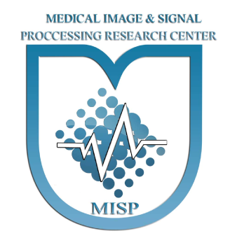
Form for applicants to participate in the Brain Plaque Detection From MRI Images Contest

Name of Team:
Name of Team Leader:
Number of Members:

Email | Phone | Name
University | Major | Education

Email | Phone | Name
University | Major | Education

Email | Phone | Name
University | Major | Education

Copy Right
- The participants must use the data only for "Brain Plaque Detection From MRI Images Contest" and any other use, whether for research, commercial or advertising, is not allowed.
- Participants must be committed to maintaining data confidentiality
- Participants must be committed to not handing over data to other people or organizations.
- Any research use or publication of articles using the data will be possible only by obtaining permission from the organizers. In this situation, it is mandatory to mention the source of data receipt (according to the approval of the organizers) in all scientific outputs.

I agree with all the above conditions

Signature

Please write the information of all the group members separately in the tables and send the final form to the email below. If the information is confirmed, the link to receive the data will be sent to the participants.

misp@mui.ac.ir

